CMP6200/DIG6200
Individual Undergraduate Project (FYP)
Final Progress Review
Create an AI system that takes information of a procedurally generated level and adapt its own behaviour to work more effectively within it

Student Name: Joshua Barnes
Student ID: 23130205
Course: Computer Games Technology
Supervisor: Jan Krasniewicz
Reporting Period: 12/12/2025 to 27/02/2026

- Progress to Date – Summary
The project is currently in the prototyping and early gameplay testing phase. Since the last review, a procedurally generated level has been created, with trees and buildings placed dynamically within the environment. A simple AI system has been implemented, enabling enemies to roam randomly and chase the player when within range. A playable character was also developed to support structured testing of core interactions. The integration of procedural generation, AI behaviour, and player systems establishes a functional gameplay foundation and confirms the technical feasibility of the core design.
2.1 Implementation and Current State
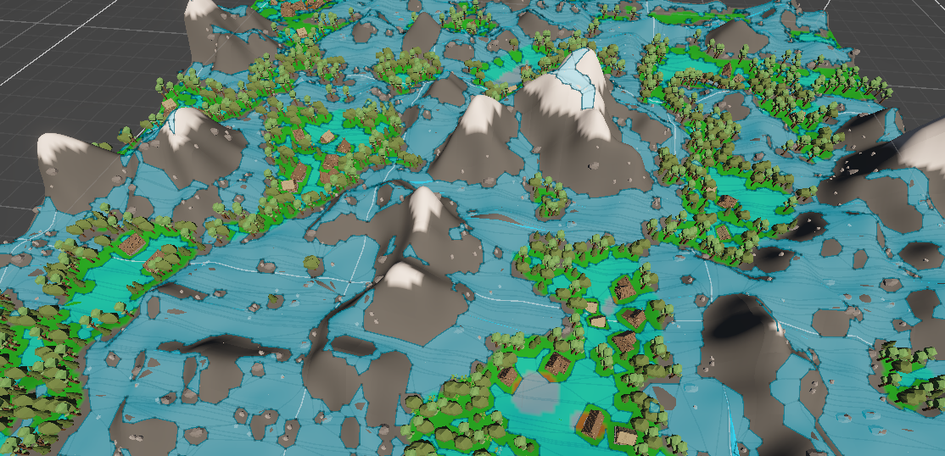
Figure 1.0 – Top-down view of the procedurally generated environment
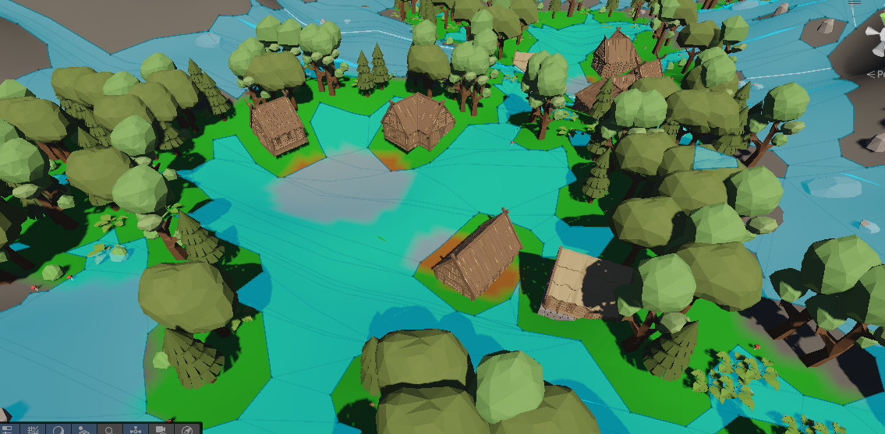
Figure 1.1 Up close view of the assets that are procedurally generated.
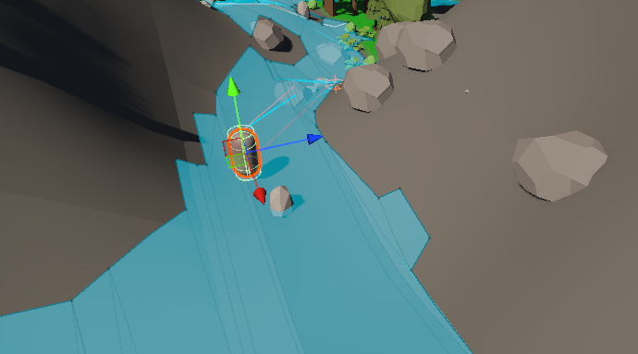
Figure 1.3 – Shows the static AI navigating the procedurally generated environment.
2.2 Analysis and Reflection
Current development shows that integrating AI into a procedurally generated environment creates more challenges in spatial awareness and navigation than in combat behaviour. Testing indicates that random roaming combined with proximity-based chasing produces functional behaviour; however, immersion is influenced more by how naturally the AI moves through and reacts to the environment. The structure of the environment, including the placement of buildings and trees, has a strong impact on how intelligent the AI appears, even when the behaviour logic is simple.
These results support the assumption that interpreting the environment at runtime improves immersion. They also show that environmental awareness is more important than simply adding more behaviour types. The artefact addresses the original problem by creating a dynamic PCG environment where AI behaviour can be tested across different spatial layouts at runtime. During development, procedural asset placement created navigation problems that caused unnatural AI movement. The placement system was adjusted to maintain clearer paths for traversal, improving movement quality and demonstrating the close connection between AI systems and environmental generation in achieving believable behaviour.
3.1 Updated Planning for Project Completion
The highest-priority task is improving how the AI interprets environmental data. The main goal is not just procedural generation but showing that AI can use runtime environmental information to increase immersion. Without this improvement, the project would not fully meet the original objective.
The next priority is structured user testing with a suitable group of participants. This will measure whether the players fins the AI more immersive in the PCG environment and will validate the system beyond basic technical performance.
3.2 Draft Outline of Final Report
Introduction – introduce artificial intelligence and its role in procedurally generated environments, outline the importance of runtime interpretation of the environment and its effects on immersion.
Update any existing knowledge that has been researched since the start of the project.
Redefine the problem statement explaining how each objective has been approached.
Implementation- elaborate how the project was set up in unity what best practices were used in the project, discuss challenges that had been faced and how the final artefact challenges the problem statement
Evaluation – show the results attained from the project and feedback from the surveys. Discuss the success of the project in comparison to the problem and discuss its merit to tackle modern development.
Discuss how any of the findings from the project may introduce future relevant work

